# OVERVIEW AND SCOPE

| Acronym: | MODPATH | HISI ID: | [] | Software Grade: | [C] |
| --- | --- | --- | --- | --- | --- |

This Software Test Plan (STP) is required by PRC-PRO-IRM-309, *Controlled Software Management*, to define the testing requirements for MODPATH and related codes for CH2M HILL Plateau Remediation Company (CHPRC) intended use in risk and model integration work.

MODPATH and related codes are managed as acquired, commercial off-the-shelf (COTS) software applications. The CHPRC plans to use this for calculations of short- and long-term subsurface water and contaminant transport in the unconfined aquifer at the Hanford Site at several scales. The software will run on desktop computers, scientific workstations, and large computer clusters.

The test procedures apply to all of the software being tested, although tests are limited to representative problems for the class of problems expected to be solved at the Hanford Site to demonstrate applicability for intended use by the CHPRC Integration and Assessments Group.

The MODFLOW calculational software configuration items tested in this STP are:

* **MODPATH**
* **[SSPA modpath?]**
* **MODPATH3DU** (variant of MODPATH which calculates particle pathlines on unstructured flow grids)

Supporting software, as identified in [CHPRC-00257, *MODFLOW and Related Codes Functional Requirements Document* (Nichols 2009b) (FRD)], are not tested in this STP because these were not classified as safety software or graded to a level requiring testing.

[Controlled use of this software is managed by CHPRC-00258, *MODFLOW and Related Codes Software Management Plan* (Nichols 2009c) (SMP). The major milestone of the test procedures is issuance of CHPRC-00261, *MODFLOW and Related Codes Acceptance Test Report* (Nichols 2009a) (ATR) that will enable authorization for use for the above software to be granted.]

# TEST REQUIREMENTS

## Approach

The general approach for this STP is to test the MODPATH and MODPATH3DU codes each against test problems specifically chosen with the following attributes: 1) availability of an analytical solution or [comparison to someone else’s solution] to facilitate comparison to a known solution, 2) sufficiently difficult for numerical approximation techniques to resolve that the test will provide not only evidence of a correct solution but a measure of the degree of error in the solution, and 3) ability to substitute Hanford-specific parameter values where possible to facilitative demonstration of applicability for intended use. As such, acceptance criteria necessarily will rely on professional judgment at least in part to evaluate if the solution obtained from the software that implements approximate numerical solution techniques is robust enough compared to the analytical solution or the case replicated to merit acceptance. It is possible to pose easier problems for which the numerical codes will produce exactly the correct solutions, but validation against a difficult-to-resolve problem is more informative. Acceptance criteria are deliberately chosen to avoid problems that arise from comparison of extremely small values that can give large percentage differences but don’t represent any significant difference.

The sequence of testing activities is discussed in the presentation of the test cases in Section 3.3.

## Deliverables

This STP specifies test design, test cases, and test procedures for acceptance and installation testing of MODPATH and related codes.

For acceptance testing, test results will be documented in an ATR using the format provided in the ATR format guidance referenced in PRC-PRO-IRM-309.

For installation testing, results will be documented in Software *Installation & Checkout Form* (A-6005-149).

## Control Procedures

The test cases in this STP are relatively simple and efficient to conduct and do not require formal tracking or control procedures. The test case logs will be used to document all steps and track results.

## Acceptance Criteria

Acceptance criteria will specify objective numerical tolerances for specific tests that must be met by the code in solving classical groundwater problems with Hanford-specific properties in order to pass. These criteria are specified with the test description in Section 3.3.

## Testing Tasks

[The tasks necessary to prepare for and perform testing include code installation (which may require compiling and linking source code using a Fortran compiler, depending on test environment), file transfers, checking input/output files using a text editor program, copying model results from text files using a text editor, and pasting results into Excel spreadsheets used to solve the analytic solutions that provide the basis for validation and compare results.]

### Verification & Validation tasks

Tasks necessary to prepare for verification and validation testing are routine with respect to computer usage. MODPATH and related codes must be installed. Users will run a virus scan of the host computer at completion of the software installation, consistent with requirements of PRC-PRO-IRM-309.

For acceptance testing, the following tasks will occur:

1. Log – the results of test execution, the incidents observed, and any other events pertinent to the test are to be logged on the forms provided as attachments to this STP.
2. Setup – verify that the host computer uses a suitable operating system for the MODPATH and related software, and that these software are installed, registered as appropriate, and virus-checked. If this software is not installed, complete the installation per directions received from the appropriate provider and virus-check the host computer immediately following software installation.
3. Execution – run the acceptance tests.
4. Evaluation – compare results of the acceptance test cases to the baseline results and evaluate if acceptance criteria are met.
5. Contingencies – in the event that output obtained from the acceptance tests appear flawed, the user may identify and correct errors and restart the test. All such attempts and corrective actions taken will be logged. Return to step 3.
6. Documentation – complete the required documentation of testing in the ATR.
7. Preservation – archive the MODPATH and related codes software in [MKS Integrity]™[1] to preserve the baseline as appropriate, along with the model file used for the acceptance test.
8. Review – independent technical review of test results is required and will be documented in the ATR.

For installation testing, the following tasks will occur:

1. Setup – verify that the host computer uses a suitable operating system for the MODPATH and related codes software, and that software is installed, registered as appropriate, and virus-checked. If the software is not installed, complete the installation and virus-check the host computer immediately following installation.
2. Execution – run the installation tests
3. Evaluation – Compare results of the installation test case to the baseline results and evaluate if acceptance criteria are met.
4. Documentation – complete the required documentation of installation testing.

If software problem(s) (that is, problems with the software itself, not input or other use errors) are identified during testing, a *Problem Report/Change Request* form (A-6005-146) will be prepared by the software tester in accordance with Sections 3.4 of PRC-PRO-IRM-309; the form will document as applicable the following information:

* Nature of required change (Minor/Major)
* Disposition and Proposed Corrective Action
* Impact Analysis
* Affected Hardware components
* Affected Baseline Documentation
* Affected software (e.g., libraries, databases)
* Testing Requirements

Submit the completed *Problem Report/Change Request* form to the software owner who will respond following the process identified in the SMP.

### Responsibilities

The software owner will:

* Conduct acceptance testing, or delegate this task to a qualified MODFLOW software user
* Assign an independent technical reviewer who is not the person conducting the test to review and approve acceptance test results (the software owner may serve as the independent technical reviewer unless the software owner is also the software user).
* Ensure that acceptance testing results are documented in the ATR, obtain approvals, and issue the ATR.
* Respond to submission of *Problem Report/Change Request* forms as specified in the SMP.
* Maintain HISI entries related to software status, testing, and approval for use of MODFLOW and related codes as identified in PRC-PRO-IRM-309
* Archive a copy of the software and any vendor provided documents in the MKS Integrity™ configuration management system.

The independent technical reviewer will:

* Review this STP and ATR or installation test results for completeness, consistency, clarity and correctness.
* Confirm acceptable test results for acceptance testing.

The software user will do the following before using a software installation to produce results that will be reported in released documents or used for decision making purposes:

* Only use versions of MODPATH and related codes that are approved for use (following completion of acceptance testing).
* When installing the MODPATH and related codes, complete the installation test identified in this STP and documents the results using *Software Installation & Checkout Form* (A-6005-149).
* Ensuring that the installation test is repeated and results documented following software or hardware configuration changes to the host computer (e.g., operating system patches or upgrades)

### Risks and Contingencies

No major risks are identified with respect to this test plan. The MODPATH and related software has a long history of successful application to similar problems as CHPRC intends to use this software to solve and is the most widely used software in the world for this purpose.

## Identification

Acceptance test cases will be identified uniquely by the following naming convention:

MP-ATC-#

MU-ATC-#

where MP designates MODPATH and MU designates MODPATH3DU; ATC designates an acceptance test case; and # is the unique test number. Similarly, installation test cases are designated by the following naming convention:

MP-ITC-# or MU-ITC-#

where ITC designates an installation test case.

## Pass/Fail Criteria

Specific pass/fail criteria for acceptance test cases are identified below in Section 3.3 for each case, and are set to ensure accurate solutions by the numerical solver in the tested software within an objective numerical tolerance. When the software is shown through the testing to meet these criteria, it will be considered to have passed the test.

## Test Cases

Four acceptance test cases and four installation test cases are detailed below with acceptance criteria and expected results for each. The tests are applicable to both MODPATH and MODPATH3DU; testing for each will be conducted and documented separately. Each of these test cases calculated the particle tracks over a flow field calculated using [either] MODFLOW [or MODFLOW3DU]. The input files for each of these tests [including for 3du?] was assembled using a python script, which utilized the [plug-ins] FloPy, matplotlib, numpy, [and anything else?].

***MP-ATC-1: Forward Particle Tracking from an Injection Well***

The first test concerns forward particle tracking in a steady-state system with an injection well. This test is repeated from and compared against a test in Pollock, 1988, *Semianalytical Computation of Path Lines for Finite-Difference Models*. The injection well pumps at a constant rate of 160,00 ft3/day into a confined aquifer with a thickness of 100 ft, hydraulic conductivity of 10 ft/day (Figure 2‑1). The hydraulic head at a radial distance of 4,000 ft from the well is held constant at 100 ft (Figure 2‑2). The symmetry of the problem allows only one-fourth of the circular flow field be considered. Figure 2‑2 shows the finite-difference grid and boundary conditions used to approximate flow through one-fourth of the system shown in Figure 2‑1.

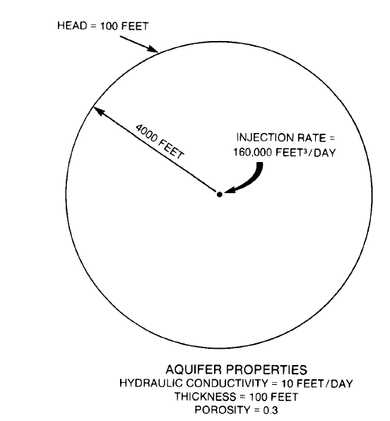

Source: Pollock, 1988

Figure 2‑1. Test Case 1 Layout

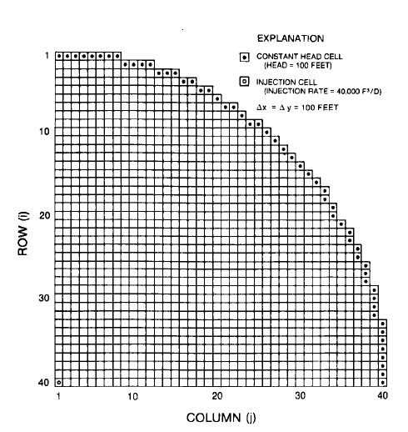

Source: Pollock, 1988

Figure 2‑2. Test Case 1 MODFLOW Setup

Ten particles were placed at a radial distance of 150 ft from the center of the well. Figure 2‑3 shows the positions of the particles after 2,500, 5,000, and 7,500 days, as calculated in Pollock, 1988. This figure was digitized and used as a guide for checking the model.

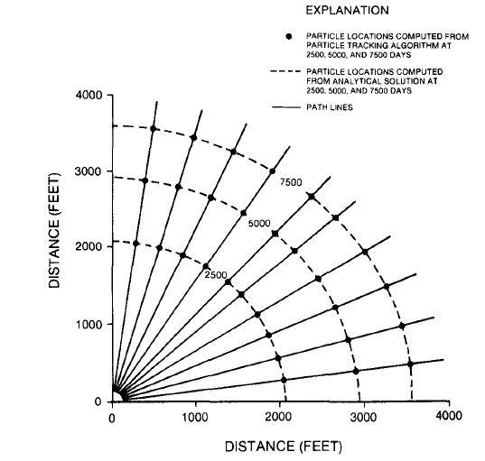

Source: Pollock, 1988

Figure 2‑3. Particle Location Over Time in Test Case 1

Model inputs are seen in Table 2‑1. Constant head cell locations are seen in Table 2‑2. The model has a single layer and has 40 rows and 40 columns each with a length and width of 100 ft. The thickness of the model is set to a uniform 100 ft. Constant head cells were assigned in the pattern shown in Figure 2‑2, and have a constant head of 100 ft. An injection well is located in the bottom left corner (row 40, column 1) and pumps at a rate of 40,000 ft3/day, representing a quarter of the pumping rate of the full-size model. The center of the well is located in the center of the cell. Starting head locations were placed in a 150-foot radius around the center of the cell in the lower left corner.

The python script which made the MODFLOW and MODPATH inputs and executed the MODFLOW and MODPATH simulations is “build_pollock_88.py”. Starting particle locations were calculated in “Write_starting_locations.py”. Constant head cell locations are listed in “chb_t1.csv”.

| Table 2‑1. Model Parameter Values for Test Case 1 | | | |
| --- | --- | --- | --- |
| Variable name | Variable Value | Units | Source |
| Number of rows | 40 | N/A | Pollock, 1988, Figure 6 |
| Number of columns | 40 | N/A | Pollock, 1988, Figure 6 |
| Height of rows | 100 | ft | Pollock, 1988, number of rows divided by radial distance of 4,000 ft |
| Width of columns | 100 | ft | Pollock, 1988, number of rows divided by radial distance of 4,000 ft |
| Number of layers | 1 | N/A | Pollock, 1988 |
| Thickness of layer | 100 | ft | Pollock, 1988 |
| Injection rate | 40,000 | ft3/day | Pollock, 1988 |
| Hydraulic conductivity (hk and vka) | 10 | ft/day | Pollock, 1988 for hk, vka assumed |
| Porosity | 0.3 | N/A | Pollock, 1988 |
| Constant head | 100 | ft | Pollock, 1988. Shape of the CHB was copied from Figure 6 |
| Starting head | 100 | ft | Assumed |
| Number of particles | 10 | N/A | Pollock, 1988 |
| Particle radial distance from center of the injection well | 150 | ft | Pollock, 1988 |
| Number of stress periods | 15 | N/A | Assumed |
| Stress period length | 500 | days | Assumed |
|  | | | |

| Table 2‑2. Constant Head Boundary Cell Locations | | | | |
| --- | --- | --- | --- | --- |
| Constant Head Boundary Cells | |  | Constant Head Boundary Cells | |
| Row | Column |  | Row | Column |
| 1 | 1 |  | 13 | 29 |
| 1 | 2 |  | 14 | 30 |
| 1 | 3 |  | 15 | 31 |
| 1 | 4 |  | 16 | 32 |
| 1 | 5 |  | 17 | 33 |
| 1 | 6 |  | 18 | 33 |
| 1 | 7 |  | 19 | 34 |
| 1 | 8 |  | 20 | 34 |
| 2 | 9 |  | 21 | 35 |
| 2 | 10 |  | 22 | 36 |
| 2 | 11 |  | 23 | 36 |
| 2 | 12 |  | 24 | 37 |
| 3 | 13 |  | 25 | 37 |
| 3 | 14 |  | 26 | 38 |
| 3 | 15 |  | 27 | 38 |
| 4 | 16 |  | 28 | 38 |
| 4 | 17 |  | 29 | 39 |
| 5 | 18 |  | 30 | 39 |
| 5 | 19 |  | 31 | 39 |
| 6 | 20 |  | 32 | 39 |
| 7 | 21 |  | 33 | 40 |
| 7 | 22 |  | 34 | 40 |
| 8 | 23 |  | 35 | 40 |
| 9 | 24 |  | 36 | 40 |
| 9 | 25 |  | 37 | 40 |
| 10 | 26 |  | 38 | 40 |
| 11 | 27 |  | 39 | 40 |
| 12 | 28 |  | 40 | 40 |

There are several sources of error in this test case. The first is that a different version of MODFLOW was used to calculate the underlying flow model. The second is that the particles were calculating using a method very similar to that used by MODPATH, but did not use the version of MODPATH tested in this document. The third is that the locations of the points at 0, 2,500, 5,000, and 7,500 days were not explicitly stated and had to be reproduced. Errors may have been introduced in the reproduction, either through the calculation of the location of the starting points, or through minor errors in the digitization of Figure 2‑3.

The acceptance criteria for this test are that the MODPATH simulation are as follows:

* Criterion 1 – the MODPATH simulation produces straight particle tracks that radiate outward
* Criterion 2 – the percent difference between the length of the flow paths digitized from Figure 2‑3 calculated value must not be more than 5%. The length of the flow paths calculated by MODPATH are calculated in post-processing by selecting the global X and Y values for each particle at the time of interest, and calculating the distance from that particle to the lower left corner of the model.

Criterion 1 gives evidence that the particle tracks are moving according to the flow direction. Criterion 2 gives evidence that the particles are moving at a speed that is within an acceptable range of similarity to the particles in Pollock, 1988. The pass/fail results are found in “tc1_results.csv”.

***MP-ATC-2: Non-Uniform Flow***

***MP-ATC-3: Capture Zone in an Isotropic Unconfined Aquifer***

This test problem for MODFLOW involves defining the shape of the capture zone of a constantly-pumping extraction well in an isotropic, unconfined aquifer with a clear hydraulic gradient. An extraction well pumping water from an aquifer will only extract water from its capture zone. MODPATH’s reverse particle tracking capabilities are commonly used to map capture zones in an unconfined aquifer in work at the Hanford Site. In this test, results from a MODPATH reverse particle tracking simulation mapping the shape of a capture zone are compared to an analytical solution describing elements of the shape of that capture zone. The analytical solution calculates the maximum width of a capture zone and stagnation point for an extraction well in an unconfined aquifer in steady-state conditions (Todd, 1980, *Groundwater Hydrology*, and Grubb, 1993, *Analytical model for estimation of steady-state capture zones of pumping wells in confined and unconfined aquifers*). MODPATH particle tracks were compared to the analytical maximum width of the aquifer and location of the stagnation point.

Assuming an unconfined, isotropic aquifer with steady hydraulic gradient in one direction, a well pumping continuously at a constant rate will produce a capture zone extend infinitely in the upgradient direction and end in the downgradient direction, as shown in Figure 2‑1.

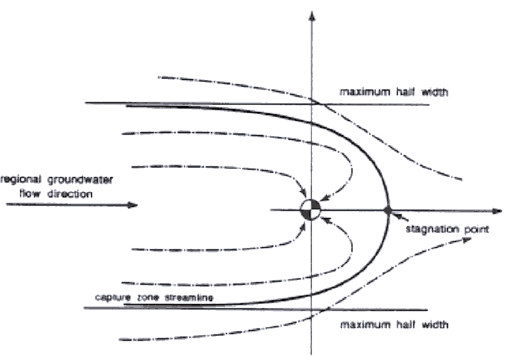

Source: Yang, Spencer, and Gates, 1995, *Analytical Solutions for Determination of Non-Steady-State and Steady-State Capture*

Figure 2‑4. Capture zone in an unconfined aquifer

The maximum width of the upgradient capture zone as measured from the center of the well (ymax­) and the stagnation point, the distance from the pumping well to the down-gradient edge of the capture zone, can be calculated analytically.

The maximum width of a capture zone of a well pumping in isotropic steady-state conditions in an unconfined aquifer is defined by the following equation from Todd 1980, Grubb 1993:

$$y_{max}= ±\frac{-QL}{K(h_{1}^{2}- h_{2}^{2})}$$

where:

*ymax* = the maximum width of the capture zone, where y0 intersects the center of the well

*Q* = the pumping rate

*L* = the distance between *h1* and *h2*

*K* = the hydraulic conductivity

*h1* = the upgradient head

*h2* = the downgradient head

The position of the stagnation point is calculated using the following equation:

$$x_{0}= \frac{-QL}{πK(h_{1}^{2}- h_{2}^{2})}$$

where:

*x0* = the stagnation point

*Q* = the pumping rate

*L* = the distance between *h1* and *h2*

*K* = the hydraulic conductivity

*h1* = the upgradient head

*h2* = the downgradient head

The values used to calculate the analytical solution are shown in Table 1. Using those values, ymax is calculated to be 160.5 ft, and x0 is calculated to be 51.1 feet. A MODFLOW model was built to reproduce this solution, and its properties are seen in Table 2. The MODFLOW model used the Q and K shown in Table 1. The left and right constant head cell values were set to h1 and h2, respectively. The width of the model was set to 40,000 meters, the L value used in the analytic method.

Reverse particle tracking was chosen to evaluate the capture zone shape. Three particles were seeded at the [right side] of the well cell, one at 50% of the cell length, one at 0.49, and one at 0.51. This was done to get as close to the boundary of the capture zone as possible.

| Table 2‑1. Model Properties Used in Analytical Solution | | |
| --- | --- | --- |
| Variable name | Variable Value | Units |
| Extraction rate (Q) | 2.5 | gal/min |
| Hydraulic conductivity (K) | 10 | ft/day |
| h1 head | 200 | ft |
| h2 head | 167.35 | ft |
| Distance between h1 and h2 (L) | 40,000 | ft |

| Table 2‑2. Model Properties | | |
| --- | --- | --- |
| **Variable name** | **Variable Value** | **Units** |
| Pumping well location | Row 201, column 311 | N/A |
| Porosity | 0.3 | N/A |
| Constant head (left) | 200 | ft |
| Constant head (right) | 167.35 | ft |
| Number of layers | 1 | N/A |
| Starting head | 200 | ft |

The ymax and x0 values were checked using a python script, ymax_and_stagnation_point.py. To evaluate ymax, this script retrieved the maximum global Y value from the endpoint file. After subtracting the y value for the midpoint of the well cell, the percent difference from the analytical ymax was calculated. The x0 was calculated in a similar manner: the script retrieved the maximum global X from the pathline file and calculated the percent difference from the analytical x0.

This test was repeated over models with square grid cell sizes of 100, 50, and 10 feet.

1. MKS is a trademark of MKS, Inc.